Diabetic retinopathy

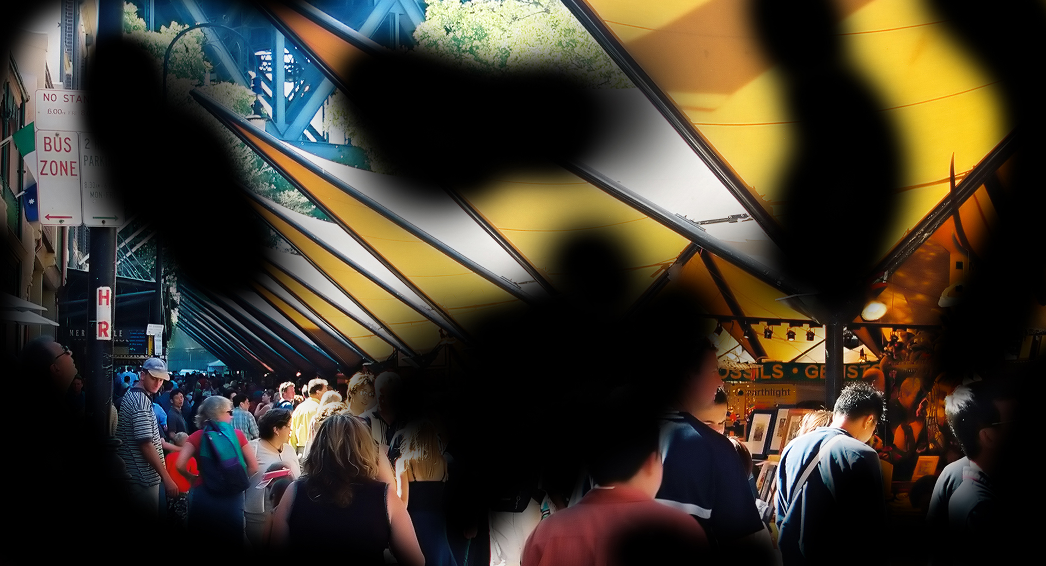
Diabetic retinopathy simulation
What is diabetic retinopathy?
Diabetic retinopathy is a complication of diabetes which can damage the tiny blood vessels inside the retina at the back of the eye. This can cause bleeding and swelling in the retina and seriously affect vision, and in some cases cause blindness.

Diabetic retinopathy is the most common cause of vision loss in people of working age in Australia.

What are the common symptoms?
There may be no symptoms in the early stages as the damaged areas may only affect the edge of the retina.

There may be blurred or distorted vision that makes it difficult to read standard print, watch television or see people’s faces.

There may be increased sensitivity to glare and difficulty seeing at night. Peripheral vision may be affected so that driving is no longer possible and there may be an increased risk of falls.

Who is at risk?
Any person who has diabetes is at risk especially if they have:
- High blood-sugar levels or poorly managed diabetes
- High blood pressure, particularly if they also have kidney disease
- A long history of diabetes

Can diabetic retinopathy be treated?
There is a range of treatments available to minimise the vision loss associated with diabetic retinopathy. This includes laser and other surgical procedures and injections.

Early detection and treatment can slow the progression of the disease and greatly decreases the risk of vision loss.

How can people with diabetes reduce the risk of vision loss from diabetic retinopathy?
- See an eye care professional regularly because there may not be any symptoms with early diabetic retinopathy
- Take prescribed medicines as instructed and follow a healthy diet
- Controlling blood-sugar levels is critical to minimise the risk of progression

How can Vision Australia help?
Vision Australia provides support and services to people of all ages and stages of life who are blind or have vision loss.

We work with people to achieve what’s important to them such as studying, finding or retaining employment, leading an active social life or continuing to do the things they love.

With the support of our professional teams, people who are blind or have low vision can develop their skills and make use of technology and equipment that will enable them to live independently.

Contact Vision Australia
Call 1300 84 74 66
Email info@visionaustralia.org
Website visionaustralia.org
Locations VIC | ACT | NSW | QLD | WA

